# Comparing mine and initial implementation of NHS Cervical Screening Algorithm

**If cytology is all false negatives, mine performs better.** This is because negative cytologies prompt a 12-month followup HPV test, which, if positive, prompts another cytology. After 3 rounds of this, the outcome of the cytology doesn’t affect whether we send the patient to coloscopy, and we always do (it just maybe effects post-coloscopy treatment, which we do not model)

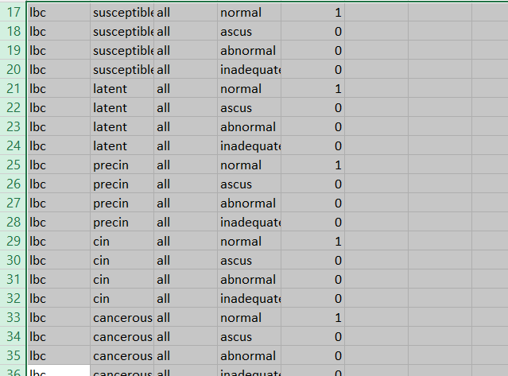

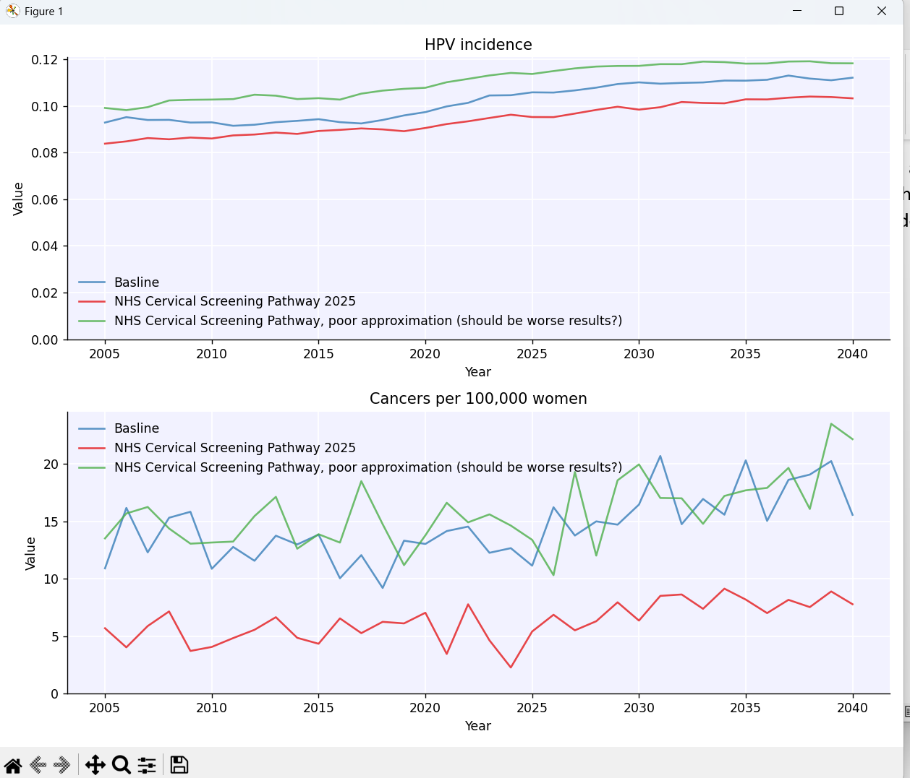

**With HPVsim’s default parameterisation for this intervention, we don’t see a big difference between the two algorithms.** Thisis because the cytology is pretty good all-round, and importantly never outputs normal for *cin* or *cancerous* state – essentially, no false negatives for these as the algorithm treats ascus and abnormal the same. Therefore, it doesn’t really matter if we do extra followups after a normal cytology (which still happen, as you can be HPV positive but only latent/precin, which would usually put you on the followup path) – as cervical cancer takes a while to develop, little is likely to change over the year or two before your followup, and you may as well just go back into the routine screening queue (as is the case with the simpler version of the alg).

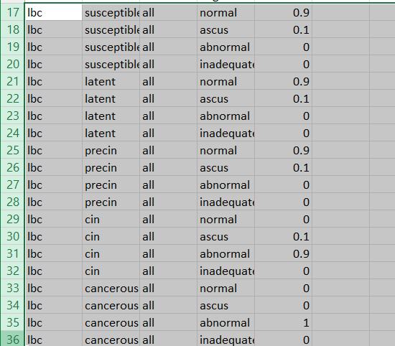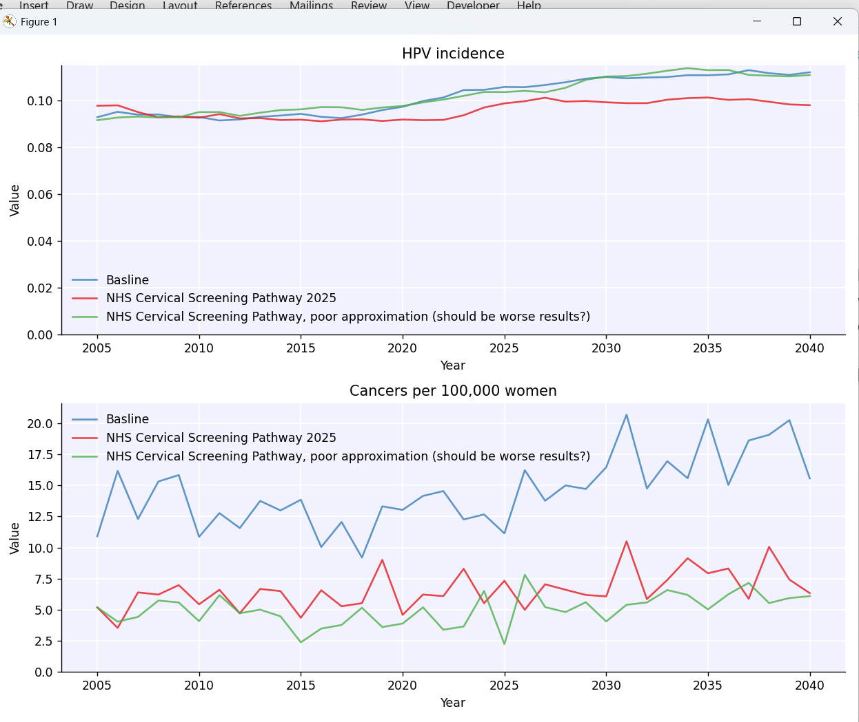

**With a very small false negative rate**, we don’t get much difference between the two.

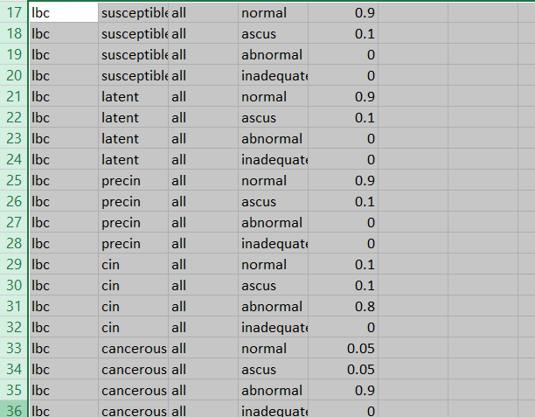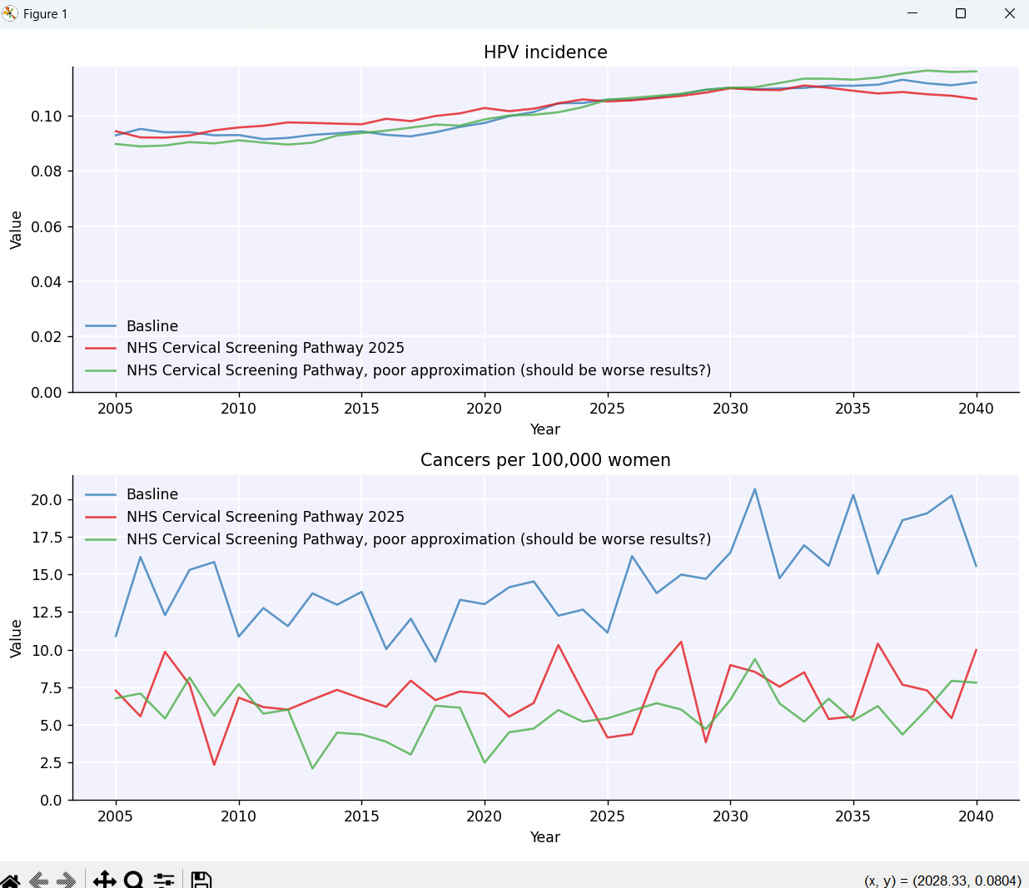

**With a larger false negative rate, still not the biggest difference.**

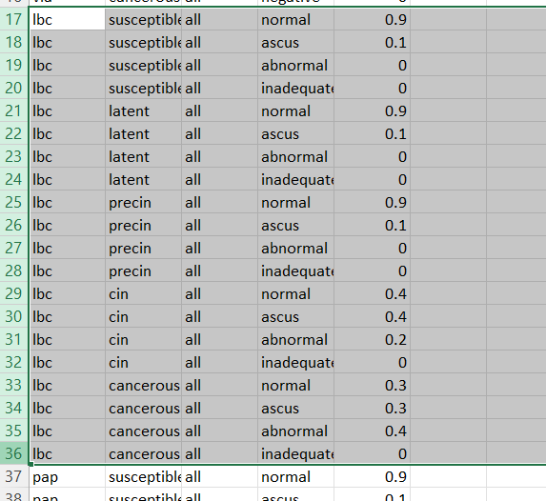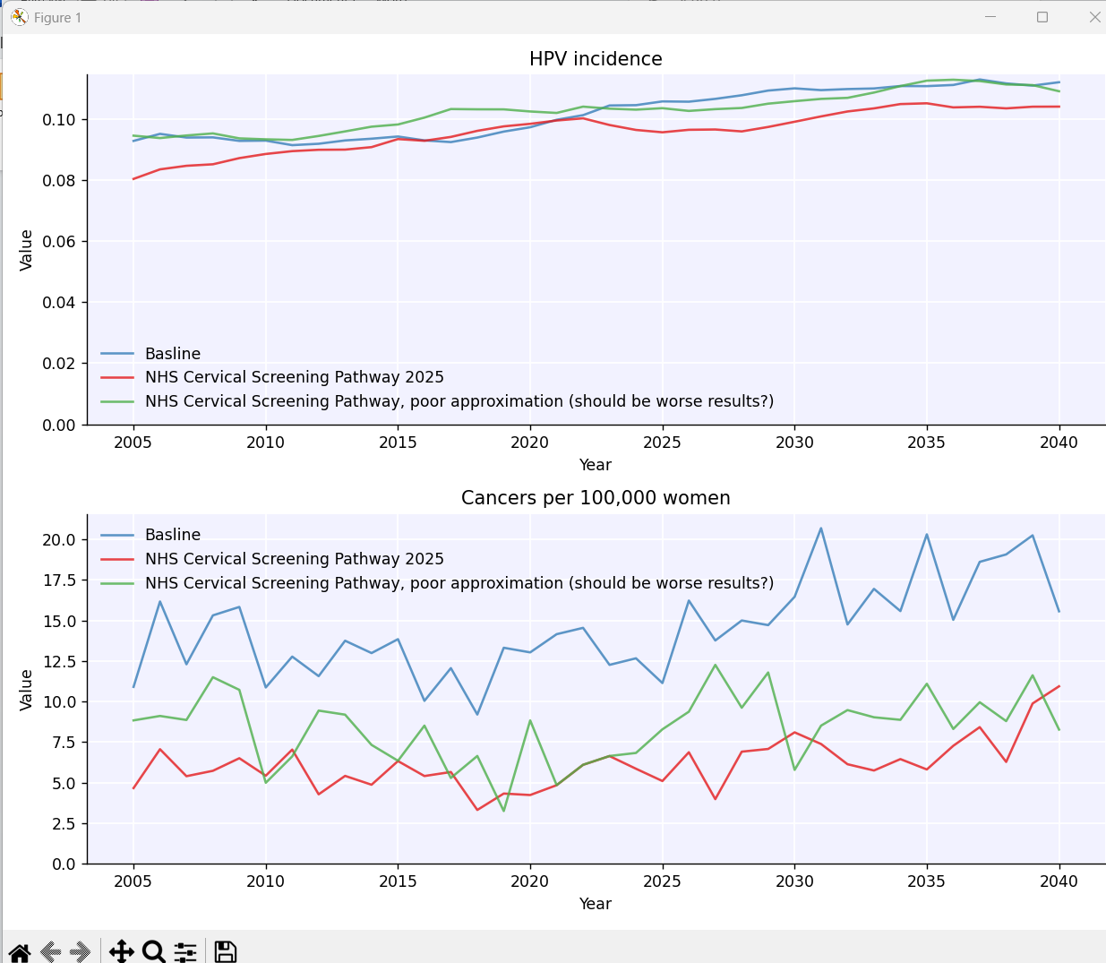

**With a larger false negative rate** (and replacing ascus diagnoses with abnormal, as they are treated the same by us anyway so it doesn’t really matter)**, we** **do start to see a difference between the two, but my alg is only just edging out the other.**

